Application Name – BackUp –Utility –V 0.1

Screenshot 1:  **Home Screen**

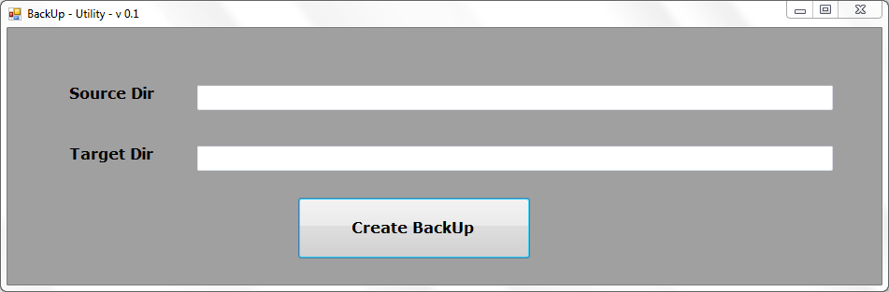

Screenshot 2:  **Selecting Directories**

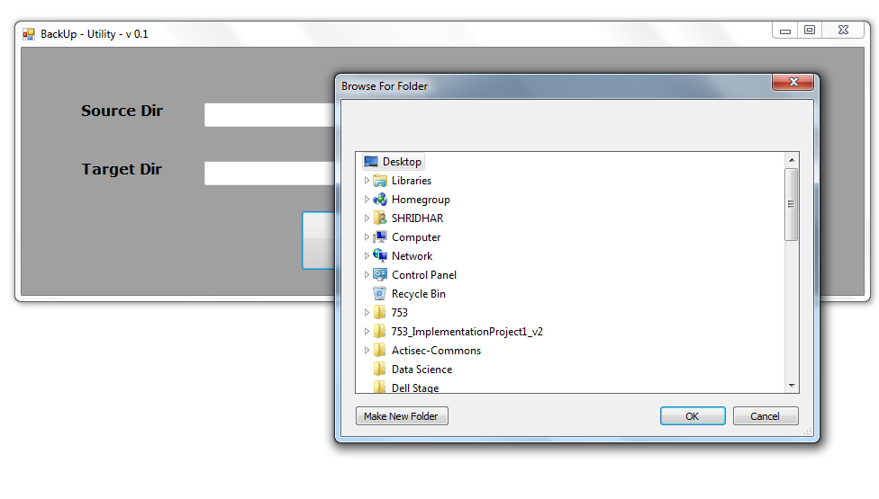

Screenshot 3:  **Final Screen**

